DataBroker Publishing Manual
A Step by Step Guide

Introduction
The purpose of this document is to step by step guide through the process a data publisher must undertake to release data, it also to provide some insight into what is happening within the DataBroker to support this process.
The steps in the process are:
- Go to the Publisher Portal;
- Selecting the appropriate Agreement Template;
- Fills in Agreement form;
- Submitting Agreement form;
- Uploads data when the Agreement becomes active;
- Check Advert details on the User Portal.

Select Agreement Template on Publisher Portal
After logging into the Publisher Portal, the list of available Agreement Templates can be viewed by selecting “New Licence”. The appropriate Agreement Template can be then selected from the list.
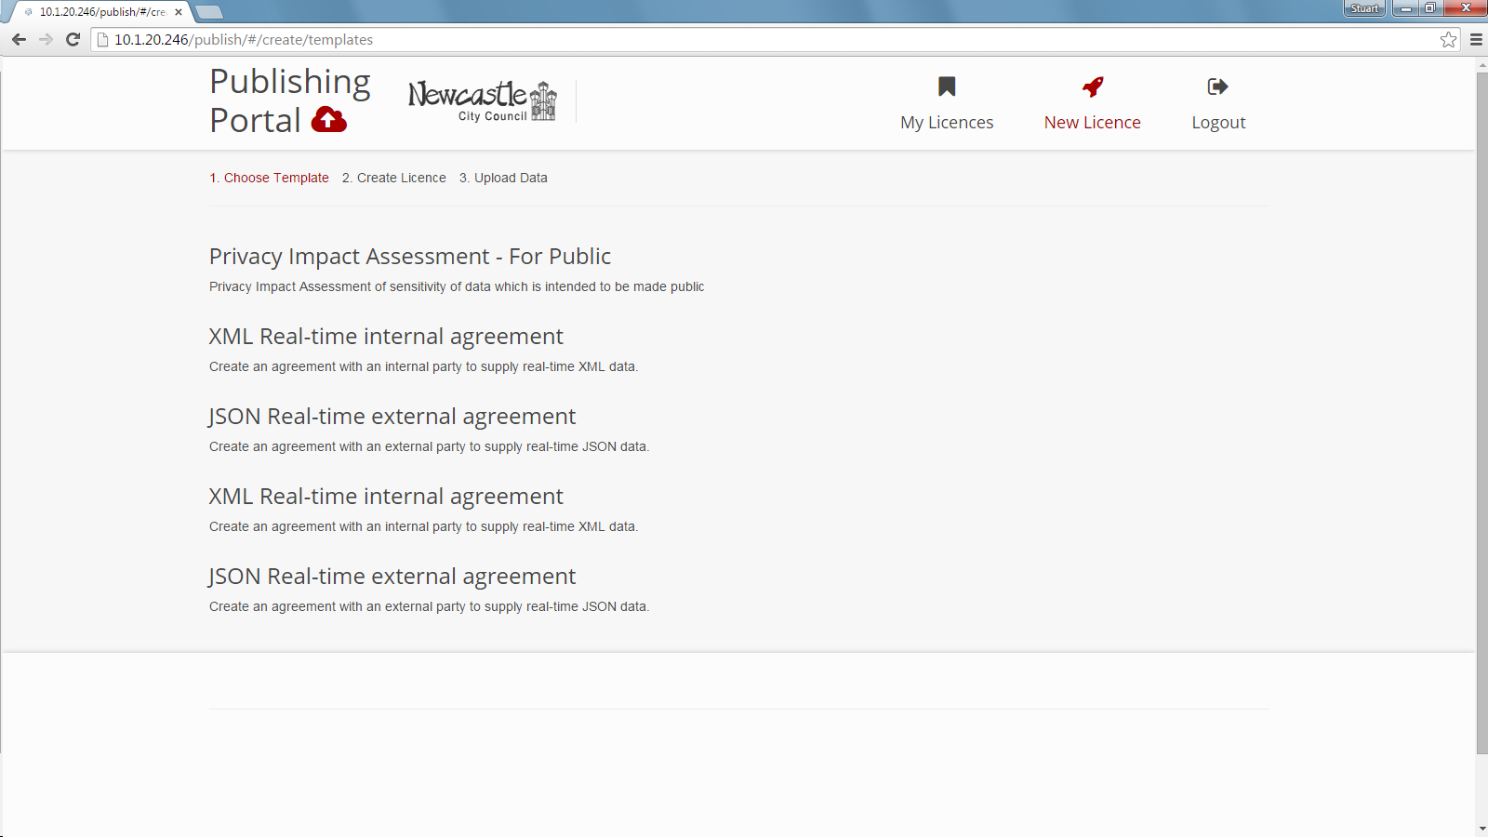

Fills in Agreement Template Form
Each Agreement Template will have different fields depending on the intended circumstances in which the Agreement should be used, and the intended outcome. Once the required fields are filled in with valid values, and any other fields with values are valid, the “Submit” button can be used.
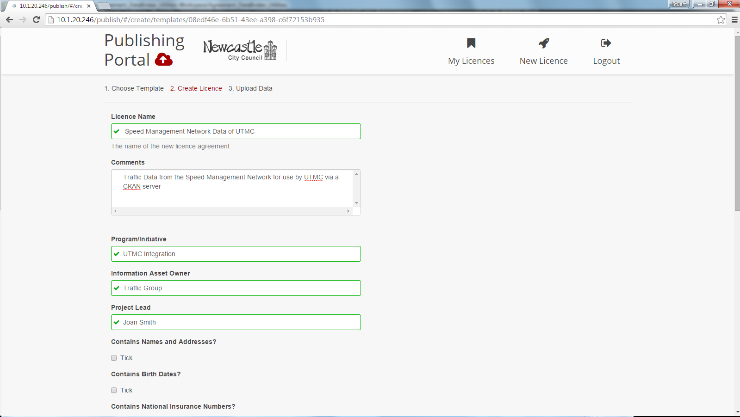

Within the DataBroker
After the initial Agreement Template form is completed and submitted, within the DataBroker it is processed and validated. If the initial Agreement is found to be permitted by policy the DataBroker will deploy an uploaded endpoint and the appropriate Data Flow to support that endpoint and the publication of the data.
Below is a screen shot of the DataBroker admin portal showing a Data Flow which is supporting the upload of data under the Agreement.
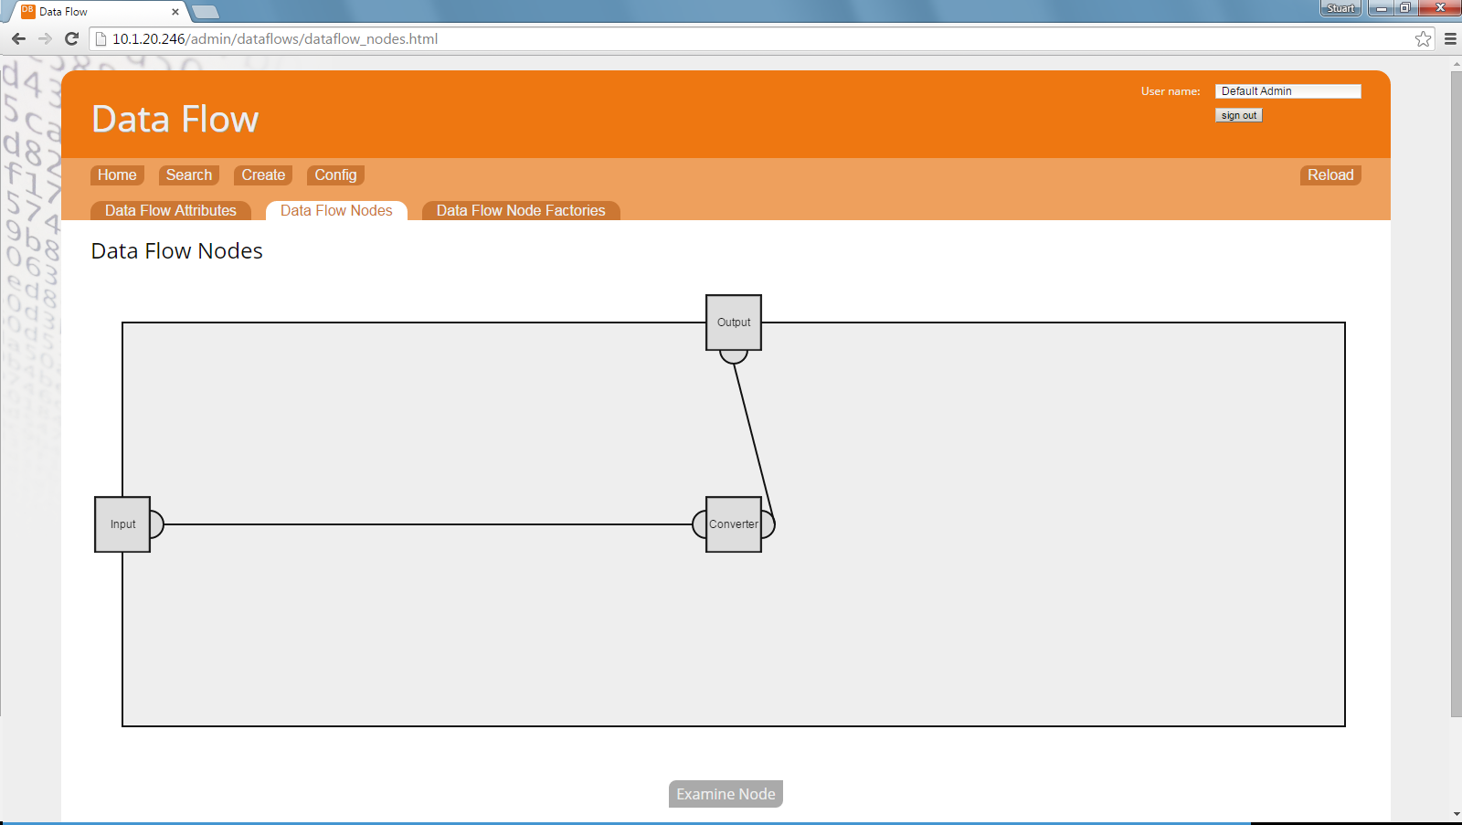

Uploading Data
Once the Agreement becomes “Active”, data can be uploaded. When “Active” the web page on the Publisher Portal which corresponds to the Agreement will include a button, “Add Data”, which allow publishers to upload data.
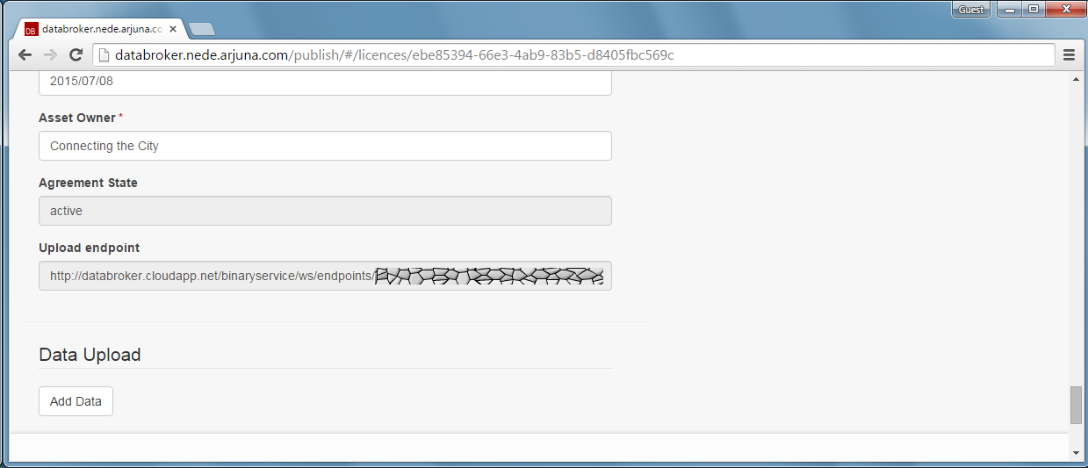

Metadata is extracted from Data
When data is uploaded via the Publisher Portal the data can be processed to extract metadata which can then be used as the basis of Adverts for the data.
Below is an example of metadata which can be extracted from the data which are uploaded.
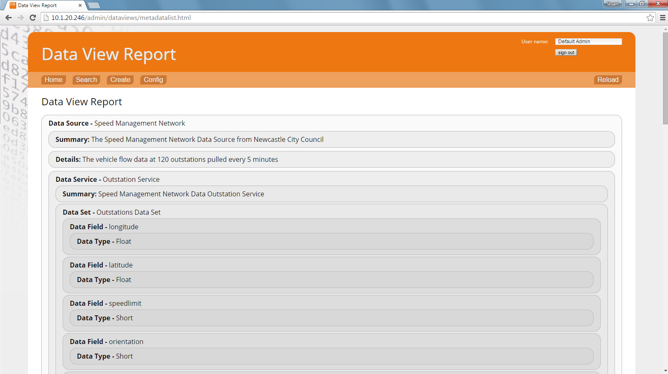

Searching Adverts User Portal
Once data has been uploaded, the User Portal can be checked to inspect the advert caused by the data upload.
The screen shot below shows the list data sets which are advertised by the DataBroker. The generated advert can be identified from the list, and selected to examine the details held.
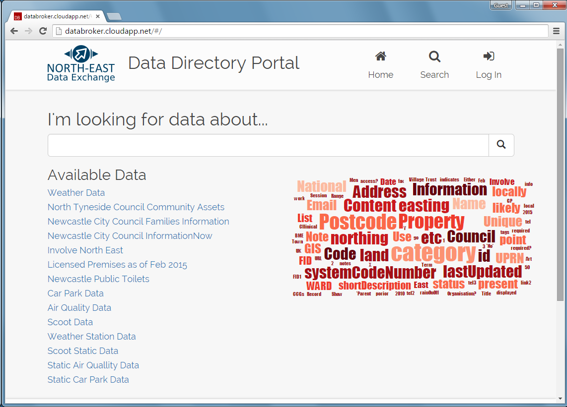

Examining Advert Details via User Portal
The details held by the DataBroker about the data uploaded can be examined via the User Portal. The structure of the data is displayed as a tree of nodes. The nodes can be selected to show further details of the corresponding part of the data structure.
